***CITY HELP CENTER***

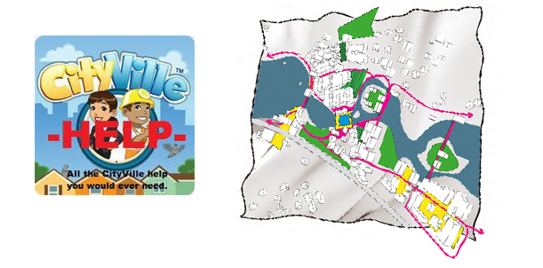

***BATCH: B -5***

***VRISHTI GAHLAUT DHRUV SINGH***

***(12103528) (12103533)***

***SUMIT BANSAL HAMZA KHAN***

***(12103530) (12103540)***

***SNAPSHOTS:***

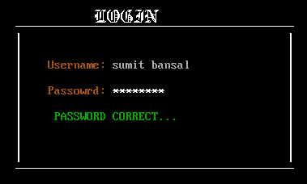

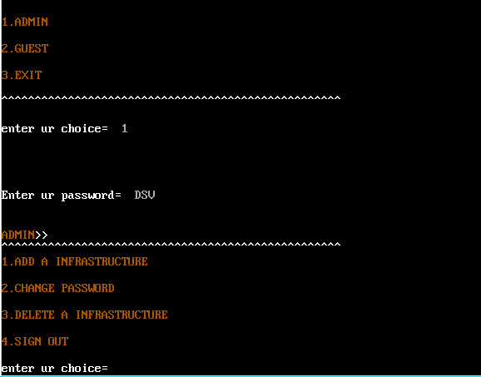

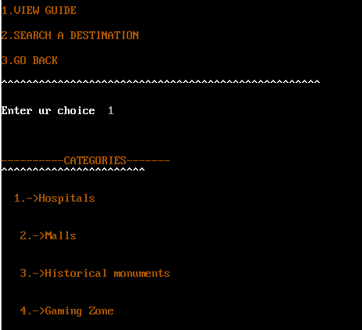

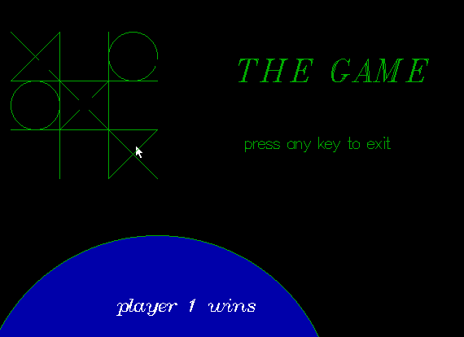

***PROBLEM:***

**Our project “CITY HELP CENTER” as the name says helps the people of the city to find the locations of the place they need to visit.**

FOR INSTANCE:

IF a person is new in city and urgently needs a hospital ,our project will help him find it and not just that it will also help him find the nearest possible location.

**Also our project can serve for entertainment purposes like for playing games like**

**TIC TAC TOE**

**BRICK BREAKER**

**So that user can enjoy!!**

Main functions used in the project:

CALL MOUSE & MOUSE POSITION:**gives the current position,the xand y coordinates of the cursor.**

**ADD PLACE**: ***adds any new infrastructures’ details to the guide.***

**ADD LIST: *Adds any new place to the category of infrastructure.***

**DISPLAY PLACE** : ***displays the list of categories.For ex. Hospital,hotels,malls etc.***

**DISPLAY LIST** : ***displays the list of places belonging to the category.***

**LOAD: *loads the game which the user* chooses to play .**

LINK LIST USED:

**IN the project we have used “multi link list” in the following way:**

**Strt->Place1-> place2->place3->place4->end**

**| | | |**

**List1 list1 list 1 list1**

**| | | |**

**List2 list2 list2 list2**

**THE categories are in the main link list while the lists are in the sub list.**

**struct place**

**{**

**char *name;**

**struct place *next;**

**struct list * down;**

**};**

**struct list**

**{**

**char *name, *add;**

**int num;**

**struct list *down;**

**};**